Visoka škola strukovnih studija za informacione i komunikacione tehnologije



DOCUMENTATION

Milica Zivanic 26/17

Sadržaj

1. Uvod
   1. O sajtu
   2. Jezici
   3. Funkcionalnost
2. Organizacija
   1. Mapa sajta
   2. Organizacija stranica
3. Korisceni kodovi
   1. HTML
      1. Index.html
      2. Shop.html
      3. Blog.html
      4. Contact.html
      5. Author.html
   2. CSS
      1. Style.css
   3. JSON
      1. Articals.json
      2. Categories.json
      3. Menu.json
      4. Products.json
      5. Sizes.json
      6. Slider.json
      7. Socials.json
   4. JAVASCRIPT
      1. Main.js
      2. Shop.js
      3. Cart.js

UVOD

UVOD

1. “Adore” je firma koja se bavi prodajom odece. Unutar sajta se nalaze proizvodi cijim klikom se otvara pojedinacni prozor za svaki proizvod sa njegovim detaljima I dugmetom sa unos u korpu.

Za proizvode je omoguceno sortiranje I filtriranje I unos vise proizvoda u korpu.

Na sajtu je takodje omogucen kontakt sa firmom preko forme kao I pretplata na mailing listu.

* 1. Tehnologije koje su korisdeni u ovom projektu: BOOTSRAP, HTML, CSS, JavaScript, JQuery, AJAX, JSON.

Okruženje u kome je kod pisan: Visual Studio Code.

* 1. Izrada Template-a : Dizajn template-a je napravljen u potpunosti od strane autora. Bootstrap koriscen za responsive klase
  2. Funkcionalnost : Na stranici index.html I shop.html se nalzi slider. Svaki proizvod na stranicama ima opciju kada se pređe mišem preko njega da prikaže blok Quick view I klikom na blok otvara se popup koji prikazuje detaljnije podatke o proizvodu i daje mogudnost dodavanja u korpu klikom na dugme ADD TO CART.(ovu funkciju poseduje svaki proizvod) Svi proizvodi su dinamički ispisani koristeci JSON. Na contact.html stranici nalazi se forma koja je u potpunosti odrađena regularnim izrazima I u koliko je došlo do nepravilnosti korisniku jasno daje do znanja gde je napravio grešku prilikom slanja podataka. Na stranici shop.html ostalim gde se nalaze proizvodi postoji mogudnost sortiranja, filtriranja I pretrage proizvoda. Pored proizvoda I drugi delovi sajta su ispisani putem JSON-a o kojim ce biti reci kasnije.

1. Organizacija
   1. Mapa sajta

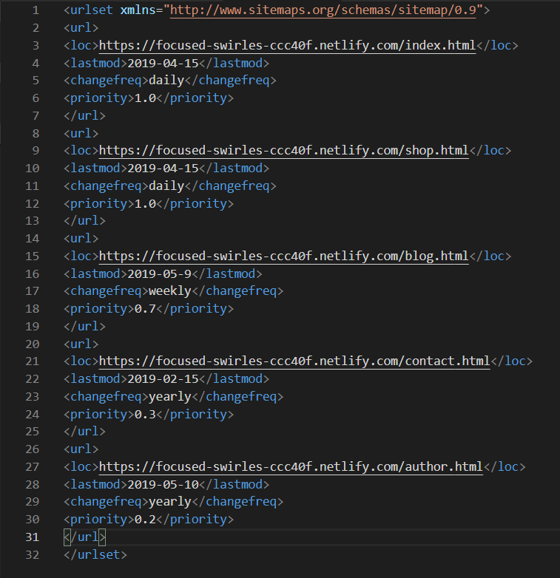

* 1. Organizacija stranica

Index.html

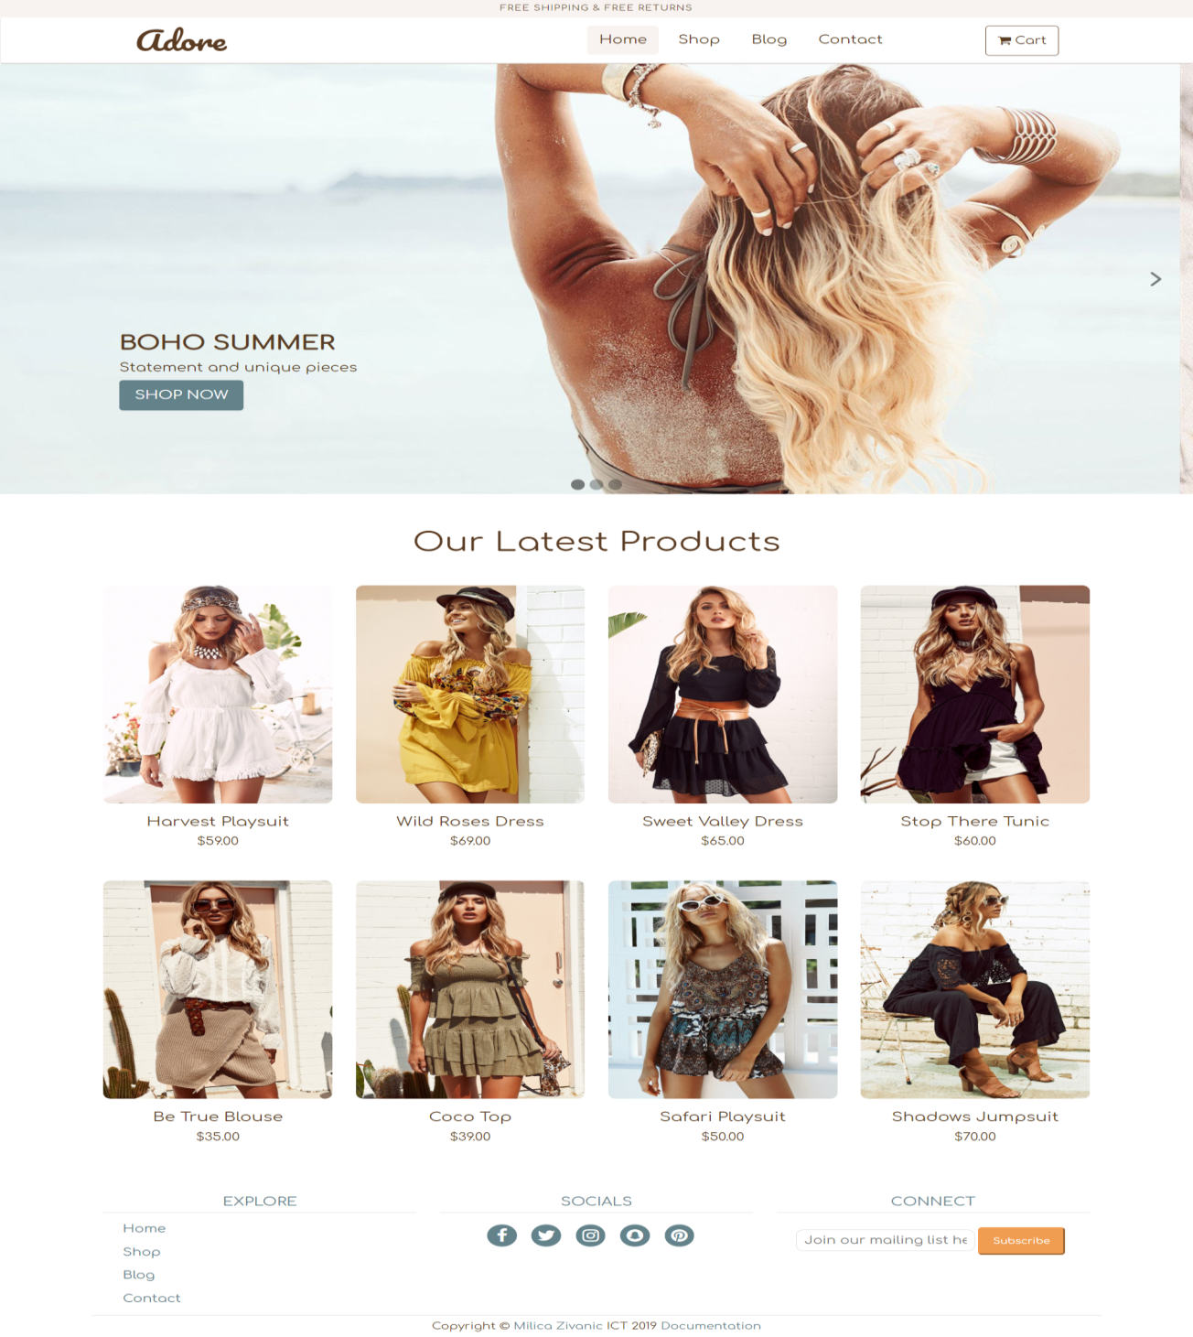

Na pocetnoj strani nalazi se dimanicki ispisan meni, dinamicki ispisan slajder napisan vanilla javascriptom, najnoviji proizvodi I footer meni takodje dimanicki ispisani. Tu je I forma za prijavu na mailing listu odradjena regularnim izrazom.

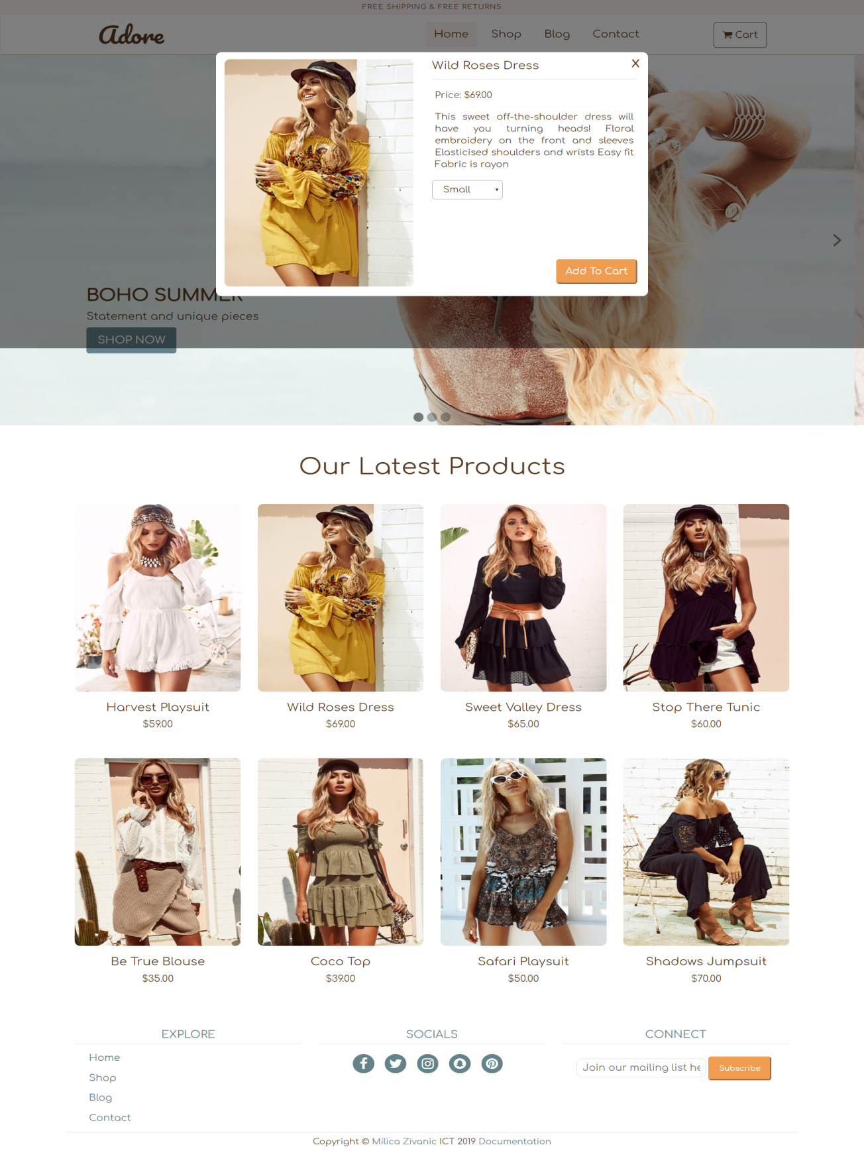

Zatim details modal koji postoji za svaki proizvod pojedinacno takodje ucitan dinamicki koji daje opciju add to cart koja ubacije proizvod u korpu. Kako je stranica skroluje tamnija povrsina prati modal.

Shop.html

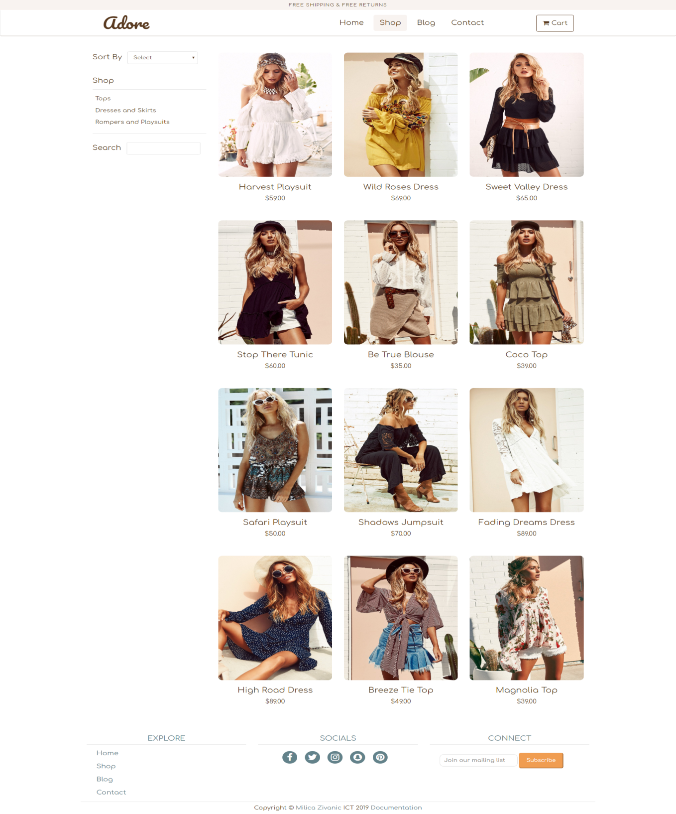

Shop stranica sadrzi proizvode sa index stranice I dodatne proizvode. Modali se pojavljuju I na ovoj stranici. Sadrzi takodje, opcije za sortiranje po ceni I nazivu opadajuce I rastuce, pretragu kao I filtriranje po karegoriji proizvoda. Kategorije su dinamicki ucitane preko JSON-a.

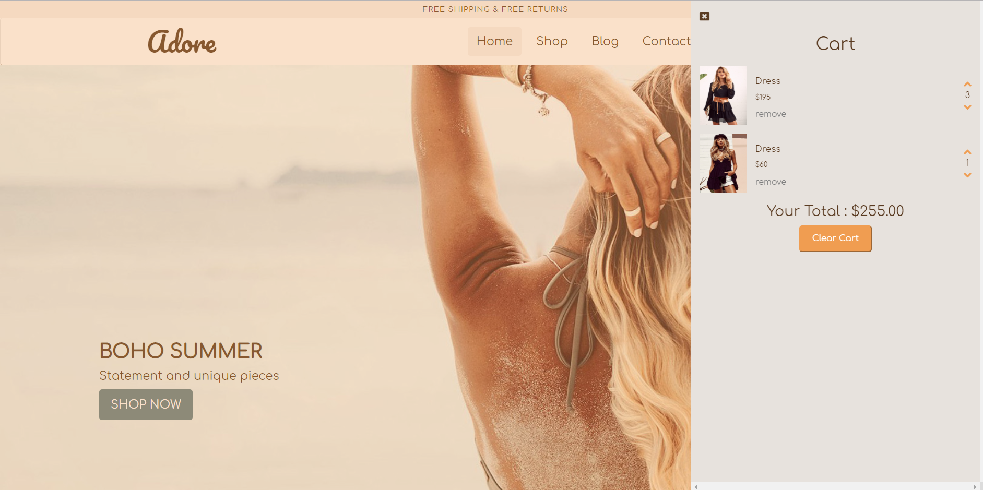

Cart je modal koji se nalazi na svakoj strain. Ima mogucnost dodavanja vise proizvoda i povecavanja njihove kolicine. Sadrzi opciju remove koja uklanja proizvod iz korpe i opciju clear cart koja brise sve sto se nalazi u korpi. Ukupna vrednost proizvoda se menja unosom.



Futer je isti na svakoj stranici I prikazuje linkove sajta, drustvene mreze I formu za prijavu na mailing listu koja je odradjenja uz pomoc regularnog izraza.

Blog.html

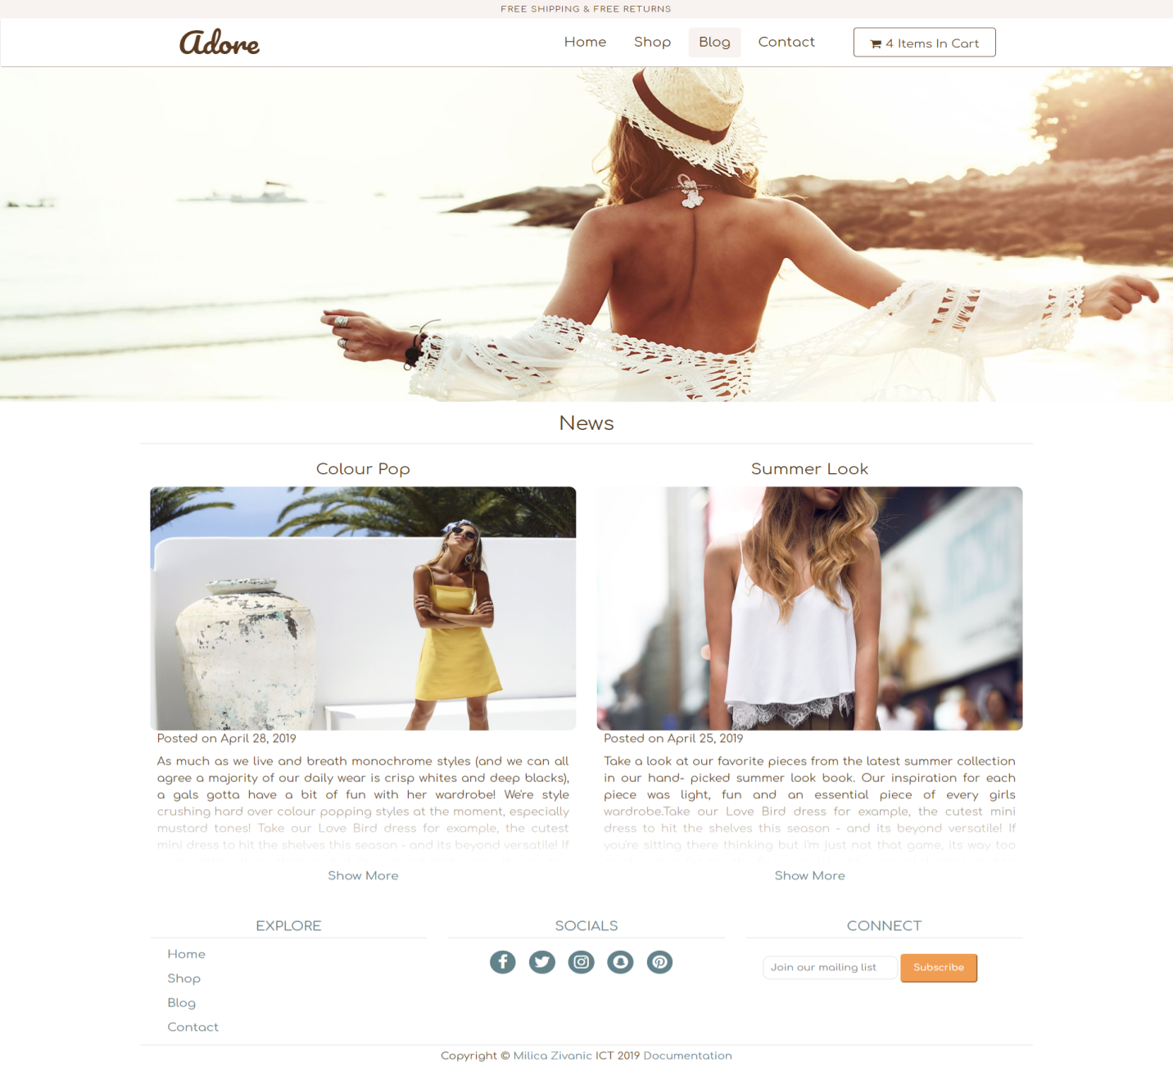

Stranica blogs prikazuje article koji su vezani za firmu. Na ovoj stranici je koriscen objektni javascript.

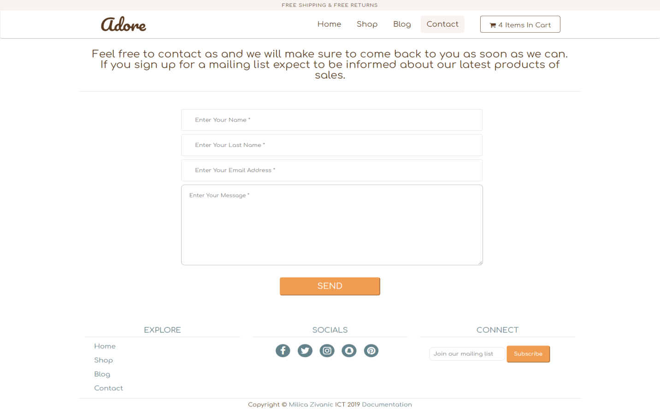

Sledeca stranica je kontakt stranica koja je takodje odradjena sa regularnim izrazima I ako korisnik uspesno unese podatke prikazuje se pop-Up koji ga time obavestava.

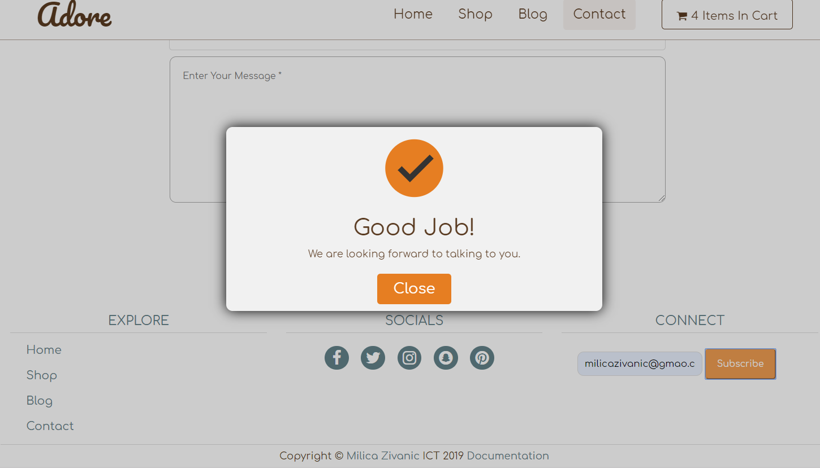

Ovaj pop Up se takodje pojavljuje I kada se korisnik prijavi na mailing listu.

Author.html

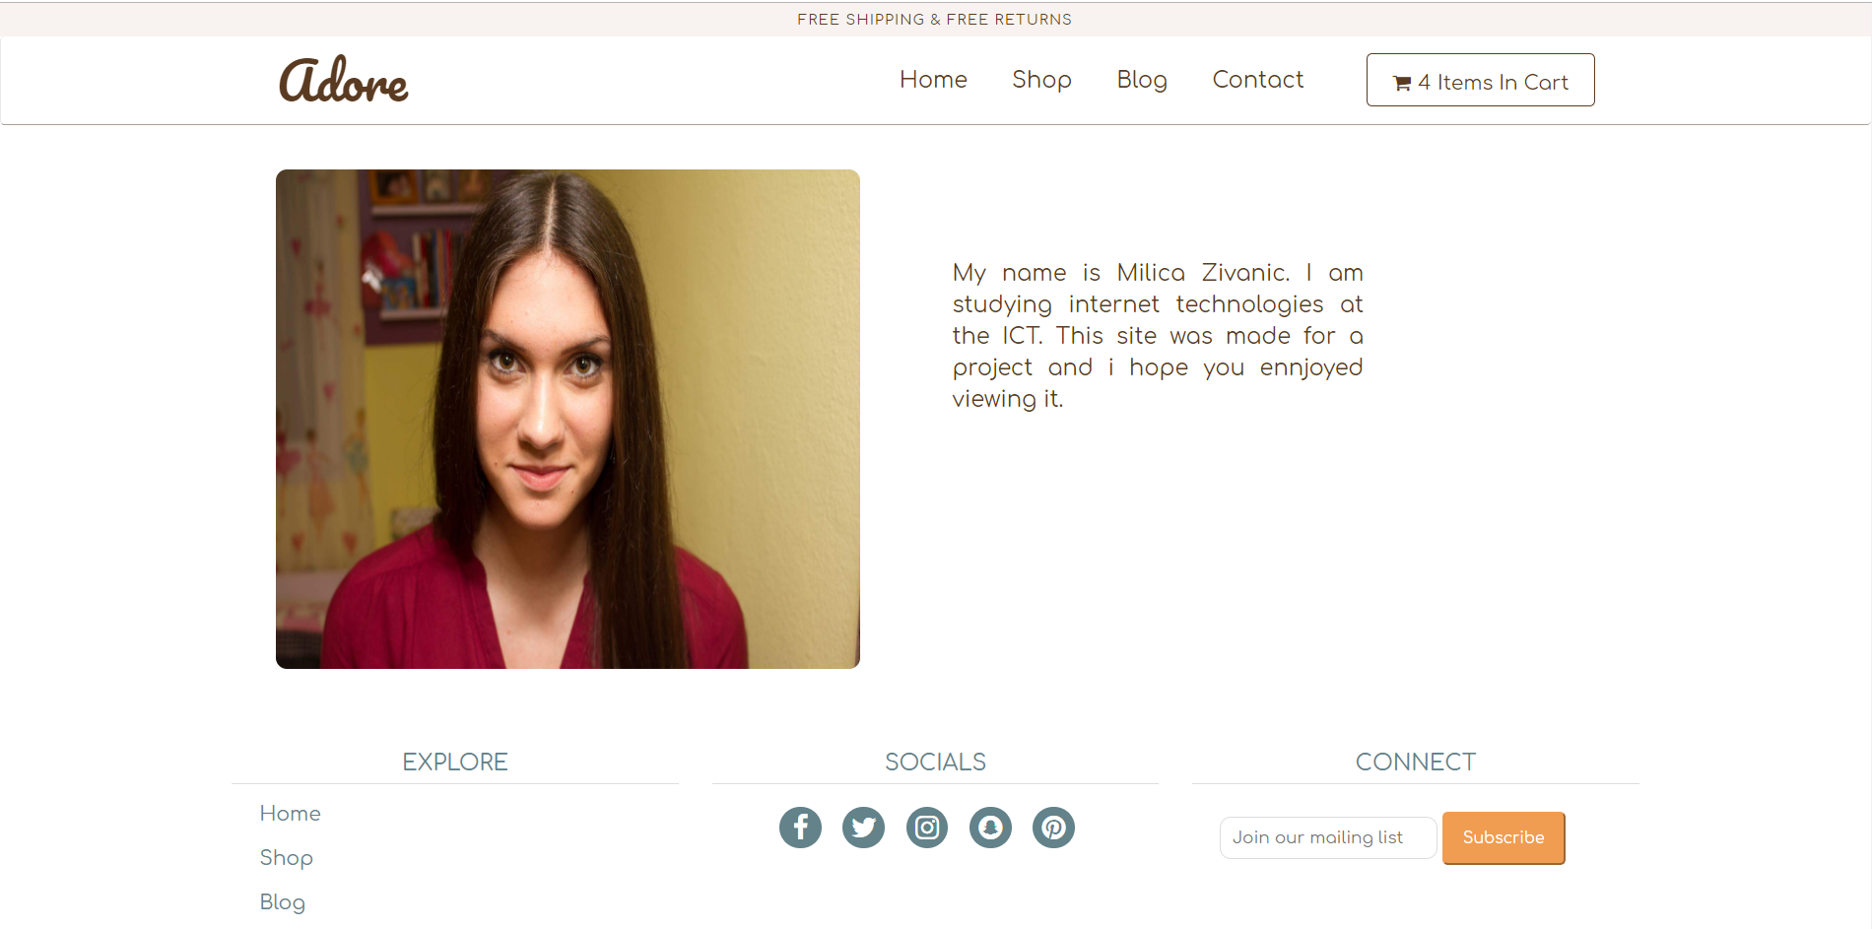

Strana o autoru

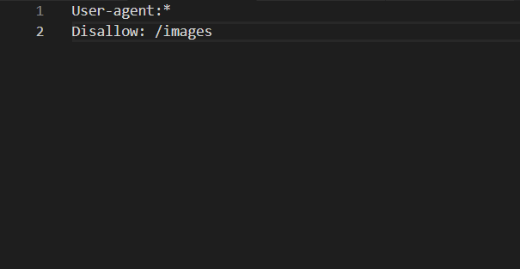

Robots.txt

1. Korisceni kodovi
   1. HTML
      1. Index.html

<!DOCTYPE html>

<html lang="en">

<head>

<meta charset="utf-8">

<meta name="viewport" content="width=device-width, initial-scale=1, shrink-to-fit=no">

<meta name="keywords" content="top, dress, playsuit, fashion, girls, rompers, shopping"/>

<meta name="author" content="Milica Zivanic"/>

<meta name="description" content="Take a look at our favorite pieces from the latest summer collection in our hand- picked summer look book.Our inspiration for each piece was light, fun and an essential piece of every girls wardrobe."/>

<link href="https://stackpath.bootstrapcdn.com/font-awesome/4.7.0/css/font-awesome.min.css" rel="stylesheet" integrity="sha384-wvfXpqpZZVQGK6TAh5PVlGOfQNHSoD2xbE+QkPxCAFlNEevoEH3Sl0sibVcOQVnN" crossorigin="anonymous">

<link href="https://fonts.googleapis.com/css?family=Comfortaa|Pacifico" rel="stylesheet">

<link rel="stylesheet" href="css/bootstrap-337.min.css"/>

<link rel="stylesheet" type="text/css" href="css/style.css"/>

<title>Adore</title>

</head>

<body>

<!-- Header -->

<div id="top-header">

<!-- Top Header -->

<div class="container-fluid" id="top">

<div class="row">

<p>FREE SHIPPING &amp; FREE RETURNS</p>

</div>

</div>

<!-- Navigation -->

<div class="navbar navbar-default">

<div class="container">

<div class="navbar-header">

<h1 id="logo"><a href="index.html">Adore</a></h1>

<button class="navbar-toggle" data-toggle="collapse" data-target="#navigation">

<span class="sr-only">Toggle Navigation</span>

<i class="fa fa-align-justify"></i>

</button>

</div>

<div class="navbar-collapse collapse" id="navigation">

<div class="padding-nav">

<ul class="nav navbar-nav" id="navigationLinks">

</ul>

</div>

<ul class="nav navbar-nav right">

<li id="cart">

<a>

<i class="fa fa-shopping-cart"></i><p class="number"></p> <p>Items In Cart</p>

</a>

</li>

</ul>

</div>

</div>

</div>

</div>

<!-- Slider-->

<div class="slider">

<div class="slider-container">

<ul class="slider-ul">

</ul>

</div>

<button class="slider-button left is-hidden">

<img src="images/left.svg" alt="Arrow Left"/>

</button>

<button class="slider-button right">

<img src="images/right.svg" alt="Arrow Right"/>

</button>

<div class="slider-indicators">

<button class="button slider-indicator current-slide"></button>

<button class="button slider-indicator"></button>

<button class="button slider-indicator"></button>

</div>

</div>

<!-- Newest products-->

<div class="container-fluid" id="latest">

<div class="row">

<h2>

Our Latest Products

</h2>

</div>

</div>

<div class="container" id="container">

<div class="row">

</div>

</div>

<!-- Modal -->

<div class="modalProduct-bg">

<div class="modalProduct">

</div>

</div>

<!-- Cart-->

<div class="cart-overlay">

<div class="cart">

<span class="close-cart">

<i class="fa fa-window-close"></i>

</span>

<h2></h2>

<div class="cart-content">

</div>

<div class="cart-footer">

<h3>Your Total : $<span class="cart-total"></span>.00</h3>

<button class="clear-cart banner-btn">Clear Cart</button>

</div>

</div>

</div>

<!-- Footer -->

<div class="container footer">

<div class="row">

<div class="col-sm-12 col-md-4 links">

<h4>EXPLORE</h4>

<ul></ul>

</div>

<div class="col-sm-12 col-md-4">

<h4>SOCIALS</h4>

<p class="social"></p>

</div>

<div class="col-sm-12 col-md-4">

<h4>CONNECT</h4>

<form action="#" method="get" id="mailList">

<input type="text" id="mailSubscribe" placeholder="Join our mailing list "/>

<button type="button" id="submit">Subscribe</button>

<div id="errorMailSubscribe">Incorrect form. Please fill out this field.</div>

</form>

</div>

</div>

</div>

<!-- Validation popup-->

<div id="box-overlay">

<div id="box">

<img src="images/gj.svg" alt="Success image">

<h1>Good Job!</h1>

<p> We are looking forward to talking to you. </p>

<a class="closeBtn">Close</a>

</div>

</div>

<div class="container-fluid" id="copyright">

<div class="row">

<h5>Copyright &copy; <a href="author.html">Milica Zivanic </a>ICT 2019 <a href="documentation.pdf">Documentation</a></h5>

</div>

</div>

<script src="js/jquery-331.min.js"></script>

<script src="js/bootstrap-337.min.js"></script>

<script type="text/javascript" src="js/main.js"></script>

<script type="text/javascript" src="js/shop.js"></script>

<script type="text/javascript" src="js/cart.js"></script>

</body>

</html>

3.1.2. Shop.html

<!DOCTYPE html>

<html lang="en">

<head>

<meta charset="utf-8">

<meta name="viewport" content="width=device-width, initial-scale=1, shrink-to-fit=no">

<meta name="keywords" content="top, dress, playsuit, fashion, girls, rompers, shopping"/>

<meta name="author" content="Milica Zivanic"/>

<meta name="description" content="Take a look at our favorite pieces from the latest summer collection in our hand- picked summer look book. Our inspiration for each piece was light, fun and an essential piece of every girls wardrobe."/>

<link href="https://stackpath.bootstrapcdn.com/font-awesome/4.7.0/css/font-awesome.min.css" rel="stylesheet" integrity="sha384-wvfXpqpZZVQGK6TAh5PVlGOfQNHSoD2xbE+QkPxCAFlNEevoEH3Sl0sibVcOQVnN" crossorigin="anonymous">

<link href="https://fonts.googleapis.com/css?family=Comfortaa|Pacifico" rel="stylesheet">

<link rel="stylesheet" href="css/bootstrap-337.min.css"/>

<link rel="stylesheet" type="text/css" href="css/style.css"/>

<title>Adore</title>

</head>

<body>

<!-- Header -->

<div id="top-header">

<!-- Top Header -->

<div class="container-fluid" id="top">

<div class="row">

<p>FREE SHIPPING &amp; FREE RETURNS</p>

</div>

</div>

<!-- Navigation -->

<div class="navbar navbar-default">

<div class="container">

<div class="navbar-header">

<h1 id="logo"><a href="index.html">Adore</a></h1>

<button class="navbar-toggle" data-toggle="collapse" data-target="#navigation">

<span class="sr-only">Toggle Navigation</span>

<i class="fa fa-align-justify"></i>

</button>

</div>

<div class="navbar-collapse collapse" id="navigation">

<div class="padding-nav">

<ul class="nav navbar-nav" id="navigationLinks">

</ul>

</div>

<ul class="nav navbar-nav right">

<li id="cart">

<a>

<i class="fa fa-shopping-cart"></i><p class="number"></p> <p>Items In Cart</p>

</a>

</li>

</ul>

</div>

</div>

</div>

</div>

<!-- Shop -->

<div class="container">

<div class="col-md-3 sidebar">

<label>Sort By</label>

<select id="sort">

<option value="0">Select</option>

<option value="a-z">Alphabeticaly, A-Z</option>

<option value="z-a">Alphabeticaly, Z-A</option>

<option value="lowHigh">Price, low to high</option>

<option value="highLow">Price, high to low</option>

</select>

<span class="linija"></span>

<h2>Shop</h2>

<ul id="categories"></ul>

<span class="linija"></span>

<label for="search">Search</label>

<input type="text" id="search"/>

</div>

<div class="col-md-9" id="all">

<div class="row">

</div>

</div>

</div>

<!-- Modal -->

<div class="modalProduct-bg">

<div class="modalProduct">

</div>

</div>

<!-- Cart-->

<div class="cart-overlay">

<div class="cart">

<span class="close-cart">

<i class="fa fa-window-close"></i>

</span>

<h2></h2>

<div class="cart-content">

</div>

<div class="cart-footer">

<h3>Your Total : $<span class="cart-total"></span>.00</h3>

<button class="clear-cart banner-btn">Clear Cart</button>

</div>

</div>

</div>

<!-- Footer -->

<div class="container footer">

<div class="row">

<div class="col-sm-12 col-md-4 links">

<h4>EXPLORE</h4>

<ul></ul>

</div>

<div class="col-sm-12 col-md-4">

<h4>SOCIALS</h4>

<p class="social"></p>

</div>

<div class="col-sm-12 col-md-4">

<h4>CONNECT</h4>

<form action="#" method="get" id="mailList">

<input type="text" id="mailSubscribe" placeholder="Join our mailing list "/>

<button type="button" id="submit">Subscribe</button>

<div id="errorMailSubscribe">Incorrect form. Please fill out this field.</div>

</form>

</div>

</div>

</div>

<!-- Validation popup-->

<div id="box-overlay">

<div id="box">

<img src="images/gj.svg" alt="Success image">

<h1>Good Job!</h1>

<p> We are looking forward to talking to you. </p>

<a class="closeBtn">Close</a>

</div>

</div>

<div class="container-fluid" id="copyright">

<div class="row">

<h5>Copyright &copy; <a href="author.html">Milica Zivanic </a>ICT 2019 <a href="documentation.pdf">Documentation</a></h5>

</div>

</div>

<script src="js/jquery-331.min.js"></script>

<script src="js/bootstrap-337.min.js"></script>

<script type="text/javascript" src="js/main.js"></script>

<script type="text/javascript" src="js/shop.js"></script>

<script type="text/javascript" src="js/cart.js"></script>

</body>

</html>

3.1.3. Blog.html

<!DOCTYPE html>

<html lang="en">

<head>

<meta charset="utf-8">

<meta name="viewport" content="width=device-width, initial-scale=1, shrink-to-fit=no">

<meta name="keywords" content="top, dress, playsuit, fashion, girls, rompers, shopping"/>

<meta name="author" content="Milica Zivanic"/>

<meta name="description" content="Take a look at our favorite pieces from the latest summer collection in our hand- picked summer look book. Our inspiration for each piece was light, fun and an essential piece of every girls wardrobe."/>

<link href="https://stackpath.bootstrapcdn.com/font-awesome/4.7.0/css/font-awesome.min.css" rel="stylesheet" integrity="sha384-wvfXpqpZZVQGK6TAh5PVlGOfQNHSoD2xbE+QkPxCAFlNEevoEH3Sl0sibVcOQVnN" crossorigin="anonymous">

<link href="https://fonts.googleapis.com/css?family=Comfortaa|Pacifico" rel="stylesheet">

<link rel="stylesheet" href="css/bootstrap-337.min.css"/>

<link rel="stylesheet" type="text/css" href="css/style.css"/>

<title>Adore</title>

</head>

<body>

<!-- Header -->

<div id="top-header">

<!-- Top Header -->

<div class="container-fluid" id="top">

<div class="row">

<p>FREE SHIPPING &amp; FREE RETURNS</p>

</div>

</div>

<!-- Navigation -->

<div class="navbar navbar-default">

<div class="container">

<div class="navbar-header">

<h1 id="logo"><a href="index.html">Adore</a></h1>

<button class="navbar-toggle" data-toggle="collapse" data-target="#navigation">

<span class="sr-only">Toggle Navigation</span>

<i class="fa fa-align-justify"></i>

</button>

</div>

<div class="navbar-collapse collapse" id="navigation">

<div class="padding-nav">

<ul class="nav navbar-nav" id="navigationLinks">

</ul>

</div>

<ul class="nav navbar-nav right">

<li id="cart">

<a>

<i class="fa fa-shopping-cart"></i><p class="number"></p> <p>Items In Cart</p>

</a>

</li>

</ul>

</div>

</div>

</div>

</div>

<div class="container-fluid headingImage">

<div class="row">

<img src="images/headingImage.jpg" alt="Heading Image"/>

</div>

</div>

<div class="container" id="new">

<div class="row">

<h2>

News

</h2>

<span class="linija"></span>

</div>

</div>

<div class="container blogs">

<div class="row">

</div>

</div>

<!-- Cart-->

<div class="cart-overlay">

<div class="cart">

<span class="close-cart">

<i class="fa fa-window-close"></i>

</span>

<h2></h2>

<div class="cart-content">

</div>

<div class="cart-footer">

<h3>Your Total : $<span class="cart-total"></span>.00</h3>

<button class="clear-cart banner-btn">Clear Cart</button>

</div>

</div>

</div>

<!-- Footer -->

<div class="container footer">

<div class="row">

<div class="col-sm-12 col-md-4 links">

<h4>EXPLORE</h4>

<ul></ul>

</div>

<div class="col-sm-12 col-md-4">

<h4>SOCIALS</h4>

<p class="social"></p>

</div>

<div class="col-sm-12 col-md-4">

<h4>CONNECT</h4>

<form action="#" method="get" id="mailList">

<input type="text" id="mailSubscribe" placeholder="Join our mailing list "/>

<button type="button" id="submit">Subscribe</button>

<div id="errorMailSubscribe">Incorrect form. Please fill out this field.</div>

</form>

</div>

</div>

</div>

<!-- Validation popup-->

<div id="box-overlay">

<div id="box">

<img src="images/gj.svg" alt="Success image">

<h1>Good Job!</h1>

<p> We are looking forward to talking to you. </p>

<a class="closeBtn">Close</a>

</div>

</div>

<div class="container-fluid" id="copyright">

<div class="row">

<h5>Copyright &copy; <a href="author.html">Milica Zivanic </a>ICT 2019 <a href="documentation.pdf">Documentation</a></h5>

</div>

</div>

<script src="js/jquery-331.min.js"></script>

<script src="js/bootstrap-337.min.js"></script>

<script type="text/javascript" src="js/main.js"></script>

<script type="text/javascript" src="js/shop.js"></script>

<script type="text/javascript" src="js/cart.js"></script>

</body>

</html>

3.1.4. Contact.html

<!DOCTYPE html>

<html lang="en">

<head>

<meta charset="utf-8">

<meta name="viewport" content="width=device-width, initial-scale=1, shrink-to-fit=no">

<meta name="keywords" content="top, dress, playsuit, fashion, girls, rompers, shopping"/>

<meta name="author" content="Milica Zivanic"/>

<meta name="description" content="Take a look at our favorite pieces from the latest summer collection in our hand- picked summer look book. Our inspiration for each piece was light, fun and an essential piece of every girls wardrobe."/>

<link href="https://stackpath.bootstrapcdn.com/font-awesome/4.7.0/css/font-awesome.min.css" rel="stylesheet" integrity="sha384-wvfXpqpZZVQGK6TAh5PVlGOfQNHSoD2xbE+QkPxCAFlNEevoEH3Sl0sibVcOQVnN" crossorigin="anonymous">

<link href="https://fonts.googleapis.com/css?family=Comfortaa|Pacifico" rel="stylesheet">

<link rel="stylesheet" href="css/bootstrap-337.min.css"/>

<link rel="stylesheet" type="text/css" href="css/style.css"/>

<title>Adore</title>

</head>

<body>

<!-- Header -->

<div id="top-header">

<!-- Top Header -->

<div class="container-fluid" id="top">

<div class="row">

<p>FREE SHIPPING &amp; FREE RETURNS</p>

</div>

</div>

<!-- Navigation -->

<div class="navbar navbar-default">

<div class="container">

<div class="navbar-header">

<h1 id="logo"><a href="index.html">Adore</a></h1>

<button class="navbar-toggle" data-toggle="collapse" data-target="#navigation">

<span class="sr-only">Toggle Navigation</span>

<i class="fa fa-align-justify"></i>

</button>

</div>

<div class="navbar-collapse collapse" id="navigation">

<div class="padding-nav">

<ul class="nav navbar-nav" id="navigationLinks">

</ul>

</div>

<ul class="nav navbar-nav right">

<li id="cart">

<a>

<i class="fa fa-shopping-cart"></i><p class="number"></p> <p>Items In Cart</p>

</a>

</li>

</ul>

</div>

</div>

</div>

</div>

<!-- Contact Form-->

<div class="container forma" >

<div class="row">

<h2>Feel free to contact as and we will make sure to come back to you as soon as we can. If you sign up for a mailing list expect to be informed about our latest products of sales.</h2>

<span class="linija"></span>

<form action="#" method="get">

<div id="leftContact">

<div class="name">

<input type="text" id="name" placeholder="Enter Your Name \*">

</div>

<div id="errorName">Incorrect form. First letter must be capitalized. </div>

<div class="lastname">

<input type="text" id="lastName" placeholder="Enter Your Last Name \*">

</div>

<div id="errorLastName">Incorrect form. First letter must be capitalized.</div>

<div class="mail">

<input type="text" id="mail" placeholder="Enter Your Email Address \*">

</div>

<div id="errorMail">Incorrect form. Please fill out this field.</div>

<div class="textArea">

<textarea id="message"

placeholder="Enter Your Message \*"></textarea>

</div>

<div id="errorTextArea">Please enter your message.</div>

</div>

<button type="button" id="valBtn">SEND</button>

</form>

</div>

</div>

<!-- Cart-->

<div class="cart-overlay">

<div class="cart">

<span class="close-cart">

<i class="fa fa-window-close"></i>

</span>

<h2></h2>

<div class="cart-content">

</div>

<div class="cart-footer">

<h3>Your Total : $<span class="cart-total"></span>.00</h3>

<button class="clear-cart banner-btn">Clear Cart</button>

</div>

</div>

</div>

<!-- Footer -->

<div class="container footer">

<div class="row">

<div class="col-sm-12 col-md-4 links">

<h4>EXPLORE</h4>

<ul></ul>

</div>

<div class="col-sm-12 col-md-4">

<h4>SOCIALS</h4>

<p class="social"></p>

</div>

<div class="col-sm-12 col-md-4">

<h4>CONNECT</h4>

<form action="#" method="get" id="mailList">

<input type="text" id="mailSubscribe" placeholder="Join our mailing list "/>

<button type="button" id="submit">Subscribe</button>

<div id="errorMailSubscribe">Incorrect form. Please fill out this field.</div>

</form>

</div>

</div>

</div>

<!-- Validation popup-->

<div id="box-overlay">

<div id="box">

<img src="images/gj.svg" alt="Success image">

<h1>Good Job!</h1>

<p> We are looking forward to talking to you. </p>

<a class="closeBtn">Close</a>

</div>

</div>

<div class="container-fluid" id="copyright">

<div class="row">

<h5>Copyright &copy; <a href="author.html">Milica Zivanic </a>ICT 2019 <a href="documentation.pdf">Documentation</a></h5>

</div>

</div>

<script src="js/jquery-331.min.js"></script>

<script src="js/bootstrap-337.min.js"></script>

<script type="text/javascript" src="js/main.js"></script>

<script type="text/javascript" src="js/shop.js"></script>

<script type="text/javascript" src="js/cart.js"></script>

</body>

</html>

3.1.5. Author.html

<!DOCTYPE html>

<html lang="en">

<head>

<meta charset="utf-8">

<meta name="viewport" content="width=device-width, initial-scale=1, shrink-to-fit=no">

<meta name="keywords" content="top, dress, playsuit, fashion, girls, rompers, shopping"/>

<meta name="author" content="Milica Zivanic"/>

<meta name="description" content="Take a look at our favorite pieces from the latest summer collection in our hand- picked summer look book. Our inspiration for each piece was light, fun and an essential piece of every girls wardrobe."/>

<link href="https://stackpath.bootstrapcdn.com/font-awesome/4.7.0/css/font-awesome.min.css" rel="stylesheet" integrity="sha384-wvfXpqpZZVQGK6TAh5PVlGOfQNHSoD2xbE+QkPxCAFlNEevoEH3Sl0sibVcOQVnN" crossorigin="anonymous">

<link href="https://fonts.googleapis.com/css?family=Comfortaa|Pacifico" rel="stylesheet">

<link rel="stylesheet" href="css/bootstrap-337.min.css"/>

<link rel="stylesheet" type="text/css" href="css/style.css"/>

<title>Adore</title>

</head>

<body>

<!-- Header -->

<div id="top-header">

<!-- Top Header -->

<div class="container-fluid" id="top">

<div class="row">

<p>FREE SHIPPING &amp; FREE RETURNS</p>

</div>

</div>

<!-- Navigation -->

<div class="navbar navbar-default">

<div class="container">

<div class="navbar-header">

<h1 id="logo"><a href="index.html">Adore</a></h1>

<button class="navbar-toggle" data-toggle="collapse" data-target="#navigation">

<span class="sr-only">Toggle Navigation</span>

<i class="fa fa-align-justify"></i>

</button>

</div>

<div class="navbar-collapse collapse" id="navigation">

<div class="padding-nav">

<ul class="nav navbar-nav" id="navigationLinks">

</ul>

</div>

<ul class="nav navbar-nav right">

<li id="cart">

<a>

<i class="fa fa-shopping-cart"></i><p class="number"></p> <p>Items In Cart</p>

</a>

</li>

</ul>

</div>

</div>

</div>

</div>

<div class="container autor">

<div class="row">

<div class="div col-md-6 col-sm-12">

<img src="images/author.jpeg" alt="Autor">

</div>

<div class="div col-md-6 col-sm-12">

<p>My name is Milica Zivanic. I am studying internet technologies at the ICT. This site was made for a project and i hope you ennjoyed viewing it. </p>

</div>

</div>

</div>

<!-- Cart-->

<div class="cart-overlay">

<div class="cart">

<span class="close-cart">

<i class="fa fa-window-close"></i>

</span>

<h2></h2>

<div class="cart-content">

</div>

<div class="cart-footer">

<h3>Your Total : $<span class="cart-total"></span>.00</h3>

<button class="clear-cart banner-btn">Clear Cart</button>

</div>

</div>

</div>

<!-- Footer -->

<div class="container footer">

<div class="row">

<div class="col-sm-12 col-md-4 links">

<h4>EXPLORE</h4>

<ul></ul>

</div>

<div class="col-sm-12 col-md-4">

<h4>SOCIALS</h4>

<p class="social"></p>

</div>

<div class="col-sm-12 col-md-4">

<h4>CONNECT</h4>

<form action="#" method="get" id="mailList">

<input type="text" id="mailSubscribe" placeholder="Join our mailing list "/>

<button type="button" id="submit">Subscribe</button>

<div id="errorMailSubscribe">Incorrect form. Please fill out this field.</div>

</form>

</div>

</div>

</div>

<!-- Validation popup-->

<div id="box-overlay">

<div id="box">

<img src="images/gj.svg" alt="Success image">

<h1>Good Job!</h1>

<p> We are looking forward to talking to you. </p>

<a class="closeBtn">Close</a>

</div>

</div>

<div class="container-fluid" id="copyright">

<div class="row">

<h5>Copyright &copy; <a href="author.html">Milica Zivanic </a>ICT 2019 <a href="documentation.pdf">Documentation</a></h5>

</div>

</div>

<script src="js/jquery-331.min.js"></script>

<script src="js/bootstrap-337.min.js"></script>

<script type="text/javascript" src="js/main.js"></script>

<script type="text/javascript" src="js/shop.js"></script>

<script type="text/javascript" src="js/cart.js"></script>

</body>

</html>

3.2. CSS

3.2.1. Style.css

\*{

margin: 0px;

padding: 0px;

box-sizing: border-box;

}

a{

text-decoration: none;

}

body{

color: #5a3b21;

font-family: 'Comfortaa', cursive;

}

ul{

list-style: none;

}

/\* Top Header \*/

#top{

background: #f8f3f0;

line-height: 20px;

height: 30px;

text-align:center;}

#top-header{

z-index: 1;

}

.scroll{

position: fixed;

width: 100%;

}

#top p{

color: #5a3b21;

font-size: 13px;

letter-spacing: 1px;

padding-top: 5px;

margin-bottom: 0px;

}

/\* Navigation \*/

.navbar-collapse .right{

float: right;

}

#logo{

padding: 10px 40px 20px 40px;

line-height: 20px;

font-size: 45px;

font-family: 'Pacifico', cursive;

}

#logo a,

#logo a:hover,

#logo a:focus{

text-decoration: none;

color:#5a3b21;;

}

.navbar ul.nav li {

padding: 0px 5px;

}

.navbar ul.nav > li > a{

font-size: 20px;

border-radius: 5px;

color:#5a3b21;

}

.navbar ul.nav > li > a:hover{

background-color: #f8f3f0;

transition: 0.5s;

}

.navbar-default .navbar-nav>.active>a{

background-color: #f8f3f0;

color: #5a3b21;

}

.navbar-default .navbar-nav>.active>a:hover{

background-color: #f8f3f0;

color: #5a3b21;

}

.navbar-default{

border-bottom: 1px solid rgba(90, 59, 33, 0.5);

background-color: #fff;

border-top: none;

padding: 0px;

border-right: none;

}

.padding-nav{

padding-top: 15px;

}

#navigationLinks{

margin-left: 32%;

}

.navbar{

margin-bottom: 0px;

}

#cart a{

cursor: pointer;

border:1px solid #5a3b21;

border-radius: 5px;

font-size:18px;

padding: 17px 20px 10px 20px;

}

#cart a {

display: flex;

justify-content: space-between;

}

#cart i, #cart p{

margin: 0px 3px;

}

#navigation{

margin-left:20px;

margin-right: 20px;

}

/\* Slider \*/

.slider{

position: relative;

height:750px;

width:100%;

margin: 0 auto;

}

.slider-image{

position: absolute;

width:100%;

height:100%;

object-fit: cover;

z-index: -1;

}

.slider-container{

height:100%;

position: relative;

overflow: hidden;

}

.slider-ul{

padding: 0px;

margin: 0px;

position: relative;

height: 100%;

width: 100%;

transition: transform 1s ease-in;

}

.slider-slide{

position: absolute;

top:0;

bottom:0px;

width: 100%;

}

.text{

position: absolute;

top:60%;

left:10%;

}

.text h2{

font-size: 33px;

font-weight: 600;

}

.text p{

font-size: 20px;

margin-bottom: 20px;

}

.text a{

font-size:20px;

padding: 15px 20px;

color: #fff;

background-color: #63828a;

text-decoration: none;

border-radius: 5px;

}

.slider-button{

position: absolute;

top:50%;

transform: translateY(-50%);

background: transparent;

border:0;

cursor: pointer;

}

.slider-button img{

width: 25px;

opacity: 0.5;

}

.slider-button:focus{

outline: none;

}

.left{

left:35px;

}

.right{

right:35px;

}

.slider-indicators{

display: flex;

position: absolute;

bottom: 1%;

left:50%;

transform: translateX(-50%);

}

.slider-indicator{

border:0;

border-radius: 50%;

width: 18px;

height: 18px;

background: rgba(0,0,0,.3);

margin: 0px 3px;

}

.slider-indicator:focus{

outline: none;

}

.current-slide{

background:rgba(0,0,0,.5)

}

.is-hidden{

display: none;

}

/\* Newest products \*/

#latest{

text-align: center;

margin: 40px 0px;

}

#latest h2{

font-size: 45px;

}

.product{

position: relative;

margin-bottom: 30px;

}

.single img, .shop img{

width: 100%;

height: 380px;;

border-radius: 10px;

}

.product img:last-child{

position: absolute;

top:0;

left:0;

display: none;

}

.details{

position: absolute;

top:65%;

left:30%;

background: #f09d51;

border-color:#f09d51;

display: none;

z-index: 1;

}

.single, .shop{

text-align: center;

margin-bottom: 15px;

}

.single h3, .shop h3{

font-size: 22px;

}

.single p, shop p{

font-size: 18px;

}

/\* Footer \*/

.links a{

text-decoration: none;

color: #63828a;

}

.links li{

font-size: 18px;

margin: 15px 25px;

}

.footer {

margin-top: 25px;

color: #63828a;

border-bottom: 1px solid #ddd;

}

.social a{

margin: 0px 15px 0px 0px;

display: inline-block;

color: #ffffff;

width: 38px;

height: 38px;

border-radius: 19px;

line-height: 38px;

font-size: 25px;

text-align: center;

background: #63828a;

text-decoration: none;

}

.social a:hover, #submit:hover{

background: #5a3b21;

transition: .5s;

}

.social{

padding: 10px 0px;

text-align: center;

}

.footer h4{

font-size: 20px;

border-bottom: 1px solid #ddd;

text-align: center;

padding-bottom: 7px;

}

#mailList{

padding: 15px 25px;

}

#mailList input{

padding: 10px 10px;

font-size: 15px;

border-radius: 10px;

border-width: 1px;

margin-left: 0px;

}

#mailList input:focus{

outline: none;

}

#submit{

color:#fff;

background: #f09d51;

border-color: #f09d51;

padding: 12px 17px;

border-radius: 5px;

cursor: pointer;

}

#copyright{

text-align: center;

}

#copyright h5{

font-size: 16px;

}

#copyright a{

text-decoration: none;

color: #63828a;

}

#copyright a:hover{

color:#5a3b21;

}

/\* Shop \*/

.sidebar h2, .sidebar span{

border-bottom: 1px solid #ddd;

}

.linija{

display: block;

margin-top: 15px;

border-bottom: 1px solid #ddd;

}

.sidebar h2, .sidebar label{

font-size: 20px;

font-weight: 500;

margin-top: 50px;

}

.sidebar h2{

margin-top: 25px;

padding-bottom: 15px;

}

.sidebar select, input{

border-radius: 5%;

padding-left: 10px;

font-size: 15px;

height: 38px;

line-height: 36px;

margin-left: 10px;

border: 1px solid #ddd;

}

#categories a{

text-decoration: none;

color: #5a3b21;

}

#categories li{

font-size: 16px;

padding: 7px;

}

#all{

margin-top: 50px;

text-align: center;

}

#all h3{

font-size: 22px;

}

#all p{

font-size: 17px;

}

#all .center-responsive{

margin-bottom: 15px;

}

label[for=search]{

margin-top: 30px;

}

.headingImage{

position: relative;

height: 550px;

}

.headingImage img{

position: absolute;

width:100%;

height: 550px;

object-fit: cover;

}

#new{

text-align: center;

}

.blogs img{

width: 100%;

height:400px;

border-radius: 10px;

}

.blogs h3{

text-align: center;

margin: 30px 0px 15px 0px;

}

.blogs{

text-align: center;

margin-bottom: 50px;

}

.blogs p {

padding: 0px 10px;

font-size: 17px;

text-align: justify;

line-height: 28px;

}

.blogs .date p{

margin-left: 10px;

font-size: 20px;

}

.forma h2{

text-align: center;

margin: 30px;

font-size:28px;

}

.forma{

margin-bottom: 80px;

text-align: center;

}

.js-show-more{

text-decoration: none;

color: #63828a;

font-size: 18px;

text-align: center;

cursor: pointer;

}

a.js-show-more:hover{

text-decoration: none;

}

.js-show-more:hover{

text-decoration: none;

}

.text-hidden{

height: 18rem;

overflow: hidden;

position: relative;

}

.text-hidden:after{

content: "";

position: absolute;

bottom:0;

left:0;

width: 100%;

height:100px;

background: linear-gradient(to bottom, rgba(255,255,255, 0.4) 0%, rgba(255,255,255, 1) 100%);

}

.text-visible{

height:auto;

overflow: auto;

}

#leftContact{

margin-top: 50px;

width: 100%;

}

#leftContact input{

padding: 30px 35px;

margin-bottom: 10px;

border-radius: 5px;

width: 60%;

}

#errorName, #errorLastName, #errorMail, #errorTextArea{

margin-bottom: 10px;

display: none;

}

#errorMailSubscribe{

display: none;

}

#valBtn{

width: 20%;

padding: 8px 13px;

margin-top: 30px;

border-radius: 5px;

background-color: #f09d51;

border-color: #f09d51;

font-size: 22px;

color:#fff;

}

#valBtn:focus, .details:focus, #message:focus, #leftContact input:focus, #search:focus{

outline:none;

}

#valBtn:hover{

background: #5a3b21;

background-color: #5a3b21;

color:#fff;

transition:.5s;

}

#message {

padding: 20px;

border-radius: 10px;

width:60%;

height:230px;

margin-left: 0.8%;

}

.autor img {

margin: 40px;

width:85%;

height: 450px;

border-radius: 10px;

}

.autor p{

margin-top: 120px;

margin-bottom: 30px;

font-size: 20px;

width: 60%;

text-align: justify;

}

/\* Modal \*/

.modalProduct-bg{

position: fixed;

width: 100%;

height: 100vh;

top: 0;

left: 0;

background-color: rgba(0,0,0,0.5);

display: flex;

justify-content: center;

align-items: center;

visibility: hidden;

opacity: 0;

z-index:1;

transition: visibility 0s, opacity 0.8s;

}

.product-active{

visibility: visible;

opacity: 1;

}

.modalProduct{

position:relative;

background-color: white;

width: 50%;

height: 70%;

border-radius: 10px;

z-index:1;

}

.modalProduct-close{

position: absolute;

top: 10px;

right:15px;

font-weight: bold;

cursor: pointer;

font-size: 20px;

}

.modalProduct .description{

height: 100%;

padding-left: 0px;

padding-right: 20px;

}

.modalProduct img{

width: 95%;

height: 95%;;

border-radius: 10px;

margin-top: 4%;

}

.modalProduct h5{

font-size:22px;

margin-top: 15px;

}

.modalProduct p{

font-size: 17px;

margin:20px 5px;

text-align: justify;

}

.modalProduct #sizes{

padding: 8px 15px;

font-size: 17px;

border-radius: 5px;

}

.modalProduct button{

position: absolute;

bottom: 5%;

right:5%;

padding: 10px 15px;

background-color: #f09d51;

color: #fff;

border-color: #f09d51;

border-radius:5px;

font-size:18px;

}

.modalProduct button:hover{

background-color: #5a3b21;

border-color: #5a3b21;

transition: .5s;

}

.modalProduct button:focus{

outline:none;

}

.details:active{

outline: none !important;

}

button:active{

box-shadow: none !important;

}

/\* Cart \*/

.cart-overlay{

position: fixed;

top:0;

right:0;

width: 100%;

height:100vh;

background-color: rgba(240,157,81, 0.3);

justify-content: right;

visibility: hidden;

z-index:1;

transition: all 0.5s linear;

}

.cart{

position: relative;

float: right;

width: 100%;

height:100%;

overflow: scroll;

z-index: 1;

background: rgba(231,226,221);

padding: 1.5rem;

transition: all 0.5s linear;

transform: translateX(100%);

}

.showCart{

transform: translateX(0);

}

.transparentBcg{

visibility: visible;

}

.cart-item{

display: grid;

align-items: center;

grid-template-columns: auto 1fr auto;

grid-column-gap: 1.5rem;

margin: 1.5rem 0;

}

.cart-item img{

width:80px;

height:100px;

}

.cart-item h5{

font-size: 15px;

}

.cart-item h6{

margin: 13px 0;

}

.item-amount{

text-align: center;

margin: 0px;

}

.cart-content h2{

text-align:center;

}

.remove-item{

color:grey;

cursor: pointer;

}

.clear-cart{

padding: 10px 20px;

background-color: #f09d51;

font-size: 15px;

color:#fff;

border-color: #f09d51;

border-radius: 5px;

}

.clear-cart:hover{

background-color: #5a3b21;

border-color:#5a3b21;

}

.clear-cart:focus{

outline: none;

}

.fa-chevron-up,

.fa-chevron-down{

color: #f09d51;

cursor: pointer;

}

.cart-footer{

margin-top: 2rem;

text-align: center;

}

.cart-footer h3{

margin-bottom: 1rem;

}

#box-overlay{

position: fixed;

width: 100%;

height: 100vh;

top: 0;

left: 0;

background-color: rgba(0,0,0,0.2);

display: flex;

justify-content: center;

align-items: center;

visibility: hidden;

opacity: 0;

z-index:1;

}

#box{

position: relative;

overflow: hidden;

background: #f1f1f1;

box-shadow: 0 0 20px black;

border-radius: 10px;

z-index: 9999;

padding: 10px;

text-align: center;

display: block;

width: 35%;

height: 37%;}

#box img{

width:110px;

height:110px;

}

#box p{

font-size: 16px;

}

#box .closeBtn{

font-size: 23px;

color: #fff;

padding: 8px 25px;

cursor: pointer;

background: #E67E22;

display: inline-block;

border-radius: 5px;

text-decoration: none;

margin-top: 10px;

}

#box .closeBtn:hover{

background-color: #5a3b21;

transition: 0.5s;

}

@media screen and (max-width: 768px) {

.navbar-nav {

float: left !important;

}

}

@media (min-width: 1300px){

.container {

width: 1300px;

}

}

@media (min-width: 768px){

.product{

float:left;

}

.cart{

width:30vw;

min-width: 450px;;

}

.close-cart{

font-size: 1.7rem;

cursor: pointer;

}

.cart h2{

text-transform: capitalize;

text-align: center;

margin-bottom: 2rem;

}

}

* 1. JSON
     1. Articals.json

[

{

"name":"Colour Pop",

"image": "images/articals1.jpg",

"date": "April 28, 2019",

"text":"As much as we live and breath monochrome styles (and we can all agree a majority of our daily wear is crisp whites and deep blacks), a gals gotta have a bit of fun with her wardrobe! We're style crushing hard over colour popping styles at the moment, especially mustard tones! Take our Love Bird dress for example, the cutest mini dress to hit the shelves this season - and its beyond versatile! If you're sitting there thinking but i'm just not that game, its way too much colour for me, the fix is simple! add a casual denim jacket to block the colour pop and a simple tan sandal - let the dress speak for itself without overpowering your style!However, if you're game to the nines (which we all should be a few days in the year) pair it with some bold tones (we low key love to team it with a pair of red mules) & coloured accessories to really get the colour pop ball rolling!"

},

{

"name":"Summer Look",

"image": "images/articals2.jpg",

"date": "April 25, 2019",

"text":"Take a look at our favorite pieces from the latest summer collection in our hand- picked summer look book. Our inspiration for each piece was light, fun and an essential piece of every girls wardrobe.Take our Love Bird dress for example, the cutest mini dress to hit the shelves this season - and its beyond versatile! If you're sitting there thinking but i'm just not that game, its way too much colour for me, the fix is simple! add a casual denim jacket to block the colour pop and a simple tan sandal - let the dress speak for itself without overpowering your style!However, if you're game to the nines (which we all should be a few days in the year) pair it with some bold tones (we low key love to team it with a pair of red mules) & coloured accessories to really get the colour pop ball rolling!"

}

]

* + 1. Categories.json

[

{

"id": 1,

"name": "Tops"

},

{

"id": 2,

"name": "Dresses and Skirts"

},

{

"id": 3,

"name": "Rompers and Playsuits"

}

* + 1. Menu.json

[

{

"href" : "index.html",

"text" : "Home"

},

{

"href" : "shop.html",

"text" : "Shop"

},

{

"href" : "blog.html",

"text" : "Blog"

},

{

"href" : "contact.html",

"text" : "Contact"

}

]

* + 1. Products.json

[

{

"id": 1,

"img" : "images/product1.jpg",

"imgHover":"images/productHover1.jpg",

"name":"Harvest Playsuit",

"price": 59,

"newest" : 1,

"category": {

"id": 3,

"name": "Rompers and Playsuits"

},

"sizes": [

{

"id": 1,

"name" : "Small"

},

{

"id": 2,

"name" : "Medium"

},

1. {

"id": 3,

"name": "Large"

}

],

"description":"Gorgeous playsuit with crochet detail Single button closure at back Adjustable straps Elasticised sleeves and waistband with drawstring Fabric is rayon - lined."

},

{

"id": 2,

"img" : "images/product2.jpg",

"imgHover":"images/productHover2.jpg",

"name":"Wild Roses Dress",

"price": 69,

"newest" : 1,

"category": {

"id": 2,

"name": "Dresses and Skirts"

},

"sizes": [

{

"id": 1,

"name" : "Small"

},

{

"id": 2,

"name" : "Medium"

},

{

"id": 3,

"name": "Large"

}

],

"description":"This sweet off-the-shoulder dress will have you turning heads! Floral embroidery on the front and sleeves Elasticised shoulders and wrists Easy fit Fabric is rayon"

},

{

"id": 3,

"img" : "images/product3.jpg",

"imgHover":"images/productHover3.jpg",

"name":"Sweet Valley Dress",

"price":65,

"newest" : 1,

"category": {

"id": 2,

"name": "Dresses and Skirts"

},

"sizes": [

{

"id": 1,

"name" : "Small"

},

{

"id": 2,

"name" : "Medium"

},

{

"id": 3,

"name": "Large"

}

],

"description":"You can never have too many LBD's! Sheer panelling on waist and sleeves Layered skirt Button clasp on wrist Concealed rear zip Fabric is polyester, non-stretchable Belt is NOT included, just used for styling "

},

{

"id": 4,

"img" : "images/product4.jpg",

"imgHover":"images/productHover4.jpg",

"name":"Stop There Tunic",

"price": 60,

"newest" : 1,

"category": {

"id": 1,

"name": "Tops"

},

"sizes": [

{

"id": 1,

"name" : "Small"

},

{

"id": 2,

"name" : "Medium"

},

{

"id": 3,

"name": "Large"

}

],

"description":"Must-have swing tunic in black V neckline with side cut-outs Lined skirt, unlined top We recommend wearing as a top/tunic (may be too short as a dress) Fabric is rayon "

},

{

"id": 5,

"img" : "images/product5.jpg",

"imgHover":"images/productHover5.jpg",

"name":"Be True Blouse",

"price": 35,

"newest" : 1,

"category": {

"id": 1,

"name": "Tops"

},

"sizes": [

{

"id": 1,

"name" : "Small"

},

{

"id": 2,

"name" : "Medium"

},

{

"id": 3,

"name": "Large"

}

],

"description":"Beautiful semi-sheer white blouse Frill detail with single button closure at back Elasticised sleeves Fabric is polyester, unlined and semi-sheer Standard length, not cropped"

},

{

"id": 6,

"img" : "images/product6.jpg",

"imgHover":"images/productHover6.jpg",

"name":"Coco Top",

"price":39,

"newest" : 1,

"category": {

"id": 1,

"name": "Tops"

},

"sizes": [

{

"id": 1,

"name" : "Small"

},

{

"id": 2,

"name" : "Medium"

},

{

"id": 3,

"name": "Large"

}

],

"description":"Adorable off the shoulder khaki top Shirred top Easy fit, cropped style Fabric is cotton / polyester Complete the look with the matching Coco Skirt! "

},

{

"id": 7,

"img" : "images/product7.jpg",

"imgHover":"images/productHover7.jpg",

"name":"Safari Playsuit",

"price":50,

"newest" : 1,

"category": {

"id": 3,

"name": "Rompers and Playsuits"

},

"sizes": [

{

"id": 1,

"name" : "Small"

},

{

"id": 2,

"name" : "Medium"

},

{

"id": 3,

"name": "Large"

}

],

"description":"Stunning bohemian printed playsuit with embellished top Elasticised waistband with waist tie Adjustable straps Front pockets Fabric is polyester, unlined "

},

{

"id": 8,

"img" : "images/product8.jpg",

"imgHover":"images/productHover8.jpg",

"name":"Shadows Jumpsuit",

"price": 70,

"newest" : 1,

"category": {

"id": 3,

"name": "Rompers and Playsuits"

},

"sizes": [

{

"id": 1,

"name" : "Small"

},

{

"id": 2,

"name" : "Medium"

},

{

"id": 3,

"name": "Large"

}

],

"description":"Beautiful off the shoulder jumpsuit in black Lace overlay Easy fitting pants with side pockets Elasticised shoulders and waistband Fabric is cotton / rayon Model wears Size Small and is 173cm tall Model's stats: Bust: 86cm / Waist: 63cm / Hips: 95cm "

},

{

"id": 9,

"img" : "images/product9.jpg",

"imgHover":"images/productHover9.jpg",

"name":"Fading Dreams Dress",

"price": 89,

"newest" : 0,

"category": {

"id": 2,

"name": "Dresses and Skirts"

},

"sizes": [

{

"id": 1,

"name" : "Small"

},

{

"id": 2,

"name" : "Medium"

}

],

"description":"Beautiful white lace swing dress V neckline Buttons down front Easy fit Flared sleeves Lined through the body, semi-sheer lace sleeves Fabric is cotton / polyester Model wears Size small and is 173cm tall Model's stats: Bust: 86cm / Waist: 63cm"

},

{

"id": 10,

"img" : "images/product10.jpg",

"imgHover":"images/productHover10.jpg",

"name":"High Road Dress",

"price": 89,

"newest" : 0,

"category": {

"id": 2,

"name": "Dresses and Skirts"

},

"sizes": [

{

"id": 1,

"name" : "Small"

},

{

"id": 3,

"name": "Large"

}

],

"description":"The perfect wrap-style dress! Navy and white polka dot print Gorgeous frill detail Hidden side zip Fabric is 100% cotton, not sheer If you're between sizes we recommend going down a size, slightly larger fit Model wears Size 6"

},

{

"id": 11,

"img" : "images/product11.jpg",

"imgHover":"images/productHover11.jpg",

"name":"Breeze Tie Top",

"price": 49,

"newest" : 0,

"category": {

"id": 1,

"name": "Tops"

},

"sizes": [

{

"id": 1,

"name" : "Small"

}

],

"description":"Gorgeous striped tie-up top Tie up front with concealed inner eye and hook closure Super easy fit Kimono sleeves One size fits all Fabric is rayon Model is 173cm tall and wears One Size as pictured Model's stats: Bust: 86cm"

},

{

"id": 12,

"img" : "images/product12.jpg",

"imgHover":"images/productHover12.jpg",

"name":"Magnolia Top",

"price": 39,

"newest" : 0,

"category": {

"id": 1,

"name": "Tops"

},

"sizes": [

{

"id": 2,

"name" : "Medium"

},

{

"id": 3,

"name": "Large"

}

],

"description":"Gorgeous floral printed swing top Unlined, sheer lace detail Easy fit Elasticised sleeves Fabric is rayon Model wears Size 6 and is 173cm tall Model's stats: Bust: 86cm / Waist: 63cm / Hips: 78.5cm and Size Small"

}

]

3.3.5.Sizes.json

[

{

"id": 1,

"name": "Small"

},

{

"id": 2,

"name": "Medium"

},

{

"id": 3,

"name": "Large"

}

]

3.3.6Slider.json

[

{

"src":"images/slider1.jpg",

"alt":"Slider Image",

"classLi":"slider-slide current-slider",

"classImg":"slider-image",

"header": "BOHO SUMMER",

"text" : "Statement and unique pieces",

"link" : "SHOP NOW",

"href": "shop.html"

},

{

"src":"images/slider2.jpg",

"alt":"Slider Image",

"classLi":"slider-slide",

"classImg":"slider-image",

"header" : "ALL IN THE DETAILS",

"text" : "Explore our collection",

"link" : "EXPLORE",

"href": "shop.html"

},

{

"src":"images/slider3.jpg",

"alt":"Slider Image",

"classLi":"slider-slide",

"classImg":"slider-image",

"header":"ONLY THE BEST",

"text":"Read about us on our blog",

"link": "READ",

"href": "blog.html"

}

]

3.3.7.Socials.json

[

{

"href":"https://www.facebook.com",

"name":"fa fa-facebook"

},

{

"href":"https://www.twitter.com",

"name":"fa fa-twitter"

},

{

"href":"https://www.instagram.com",

"name":"fa fa-instagram"

},

{

"href":"https://www.snapchat.com",

"name":"fa fa-snapchat"

},

{

"href":"https://www.pinterest.com",

"name":"fa fa-pinterest"

}

]

3.4. Javascript

3.4.1. Main.js

window.onload = function(){

showMenu();

showSlider();

showSocials();

printCount();

let blogs = Articals();

blogs.getArticles();

$(window).on('beforeunload', function(){

$(window).scrollTop(0);

});

var sub = document.querySelector("#submit");

sub.addEventListener("click",emailValidationSubscribe);

var button = document.querySelector("#valBtn");

button.addEventListener("click",Validation);

};

/\* Menu \*/

function showMenu(){

$.ajax({

url: "data/menu.json",

method: "GET",

dataType: "json",

success:function(data){

printMenu(data);

},

error:function(error){

console.log(error);

}

});

}

function printMenu(data){

let html = "";

for(let d of data){

html += `

<li class="nav-item ${isActiveLink(d)}">

<a class="nav-link" href="${d.href}">${d.text}</a>

</li>`

}

document.querySelector("#navigationLinks").innerHTML = html;

document.querySelector(".links ul").innerHTML = html;

}

function isActiveLink(d){

return document.URL.indexOf(d.href) != -1 || (document.URL.indexOf(".html") == -1 && d.href == "index.html") ? "active" : "";

}

function getLocalStorage(name){

return JSON.parse(localStorage.getItem(name));

}

function hasLocalStorage(name){

return JSON.parse(localStorage.getItem(name) != null);

}

function printCount(){

if(hasLocalStorage("products")){

let count = 0,

books = getLocalStorage("products");

for(let book of books){

count += book.quantity;

}

$(".number").html(count);

}

else{

$(".number").html("0")

}

}

/\* Slider \*/

function showSlider(){

$.ajax({

url: "data/slider.json",

method: "GET",

dataType: "json",

success:function(data){

printSlider(data);

},

error:function(error){

console.log(error);

}

});

}

function printSlider(data){

let html = "";

for(let d of data){

html += `

<li class="${d.classLi}">

<img src="${d.src}" alt="${d.alt}" class="${d.classImg}"/>

<div class="text">

<h2>${d.header}</h2>

<p>${d.text}</p>

<a href="${d.href}">${d.link}</a>

</div>

</li>`

}

document.querySelector(".slider-ul").innerHTML = html;

var container = document.querySelector('.slider-ul');

var slides = Array.from(container.children)

var nextButton = document.querySelector('.slider-button.right');

var prevButton = document.querySelector('.slider-button.left');

var dots = document.querySelector('.slider-indicators');

var dot = Array.from(dots.children);

var slideWidth = slides[0].getBoundingClientRect().width;

slides.forEach((slide,index) => {

slide.style.left = slideWidth \* index + "px";

});

function moveToSlide(container, currentSlide, targetSlide){

container.style.transform = "translateX(-" + targetSlide.style.left + ")";

currentSlide.classList.remove("current-slider");

targetSlide.classList.add("current-slider");

}

function updateDots(currentDot, targetDot){

currentDot.classList.remove("current-slide")

targetDot.classList.add("current-slide");

}

function hideShowArrows(slides, prevButton, nextButton, targetIndex){

if(targetIndex === 0){

prevButton.classList.add("is-hidden");

nextButton.classList.remove("is-hidden")

}else if(targetIndex === slides.length - 1){

prevButton.classList.remove("is-hidden")

nextButton.classList.add("is-hidden")

}else{

prevButton.classList.remove("is-hidden");

nextButton.classList.remove("is-hidden")

}

}

prevButton.addEventListener("click", e => {

let currentSlide = container.querySelector(".current-slider");

let prevSlide = currentSlide.previousElementSibling;

let currentDot = dots.querySelector(".current-slide");

let prevDot = currentDot.previousElementSibling;

let prevIndex = slides.findIndex(slide => slide === prevSlide);

moveToSlide(container, currentSlide, prevSlide);

updateDots(currentDot, prevDot);

hideShowArrows(slides, prevButton, nextButton, prevIndex);

});

nextButton.addEventListener("click", e => {

let currentSlide = container.querySelector(".current-slider");

let nextSlide = currentSlide.nextElementSibling;

let currentDot = dots.querySelector(".current-slide");

let nextDot = currentDot.nextElementSibling;

let nextIndex = slides.findIndex(slide => slide === nextSlide);

moveToSlide(container, currentSlide, nextSlide);

updateDots(currentDot, nextDot);

hideShowArrows(slides, prevButton, nextButton, nextIndex);

})

dots.addEventListener("click", e => {

let targetDot = e.target.closest('button');

if(!targetDot) return;

let currentSlide = container.querySelector(".current-slider");

let currentDot = dots.querySelector(".current-slide");

let targetIndex = dot.findIndex(d => d === targetDot)

let targetSlide = slides[targetIndex];

moveToSlide(container, currentSlide, targetSlide);

updateDots(currentDot, targetDot)

hideShowArrows(slides, prevButton, nextButton, targetIndex);

})

}

function showSocials(){

$.ajax({

url: "data/socials.json",

method: "GET",

dataType: "json",

success:function(data){

printSocials(data);

},

error:function(error){

console.log(error);

}

});

}

function printSocials(data){

let html= "";

for(let d of data){

html += `

<a href="${d.href}" class="${d.name}"></a>

`

}

document.querySelector(".social").innerHTML = html;

console.log()

}

function Articals(){

function getArticles(){

$.ajax({

url: "data/articals.json",

method : "get",

dataType: "json",

success: function(articals){

printBlogs(articals);

},

error: function(error){

console.log(error)

}

});

}

function printBlogs(articals){

let html = "";

for(let a of articals){

html += `

<div class="col-md-6 col-sm-12">

<div class="content">

<h3>${a.name}</h3>

<img src="${a.image}" alt="${a.name}"/>

<p class="date">Posted on ${a.date}</p>

<p class="textBlog text-hidden">${a.text}</p>

</div>

<a href="#" class="js-show-more">Show More</a>

</div>

`

}

document.querySelector(".blogs .row").innerHTML = html;

}

return {getArticles};

}

const Utils ={

addClass: function(element, theClass){

element.classList.add(theClass);

},

removeClass: function(element, theClass){

element.classList.remove(theClass);

},

showMore: function(element, excert){

element.addEventListener("click", event =>{

const linkText = event.target.textContent.toLowerCase();

event.preventDefault();

console.log(this);

if(linkText == "show more"){

element.textContent = "Show Less";

this.removeClass(excerpt, "text-hidden");

this.addClass(excerpt, "text-visible");

}else{

element.textContent == "Show more";

this.removeClass(excerpt, "text-visible");

this.addClass(excerpt, "text-hidden");

}

});

}

};

const ExcerptWidget = {

showMore: function(showMoreLinksTarget, excerptTarget){

const showMoreLinks = document.querySelectorAll(showMoreLinksTarget);

showMoreLinks.forEach(function(link){

const excerpt = link.previousElementSibling.querySelector(excerptTarget);

Utils.showMore(link, excerpt);

});

}

};

ExcerptWidget.showMore(".js-show-more", ".textBlog")

/\* Validation \*/

function Validation(){

valid = true;

nameValidation();

lastNameValidation();

emailValidation();

textAreaValidation();

if(valid){

document.querySelector("#box-overlay").style.visibility = "visible";

document.querySelector("#box-overlay").style.opacity = "1";

}

}

function nameValidation(){

var name = document.querySelector('#name');

var regName = /^[A-ZŽŠĐČĆ][a-zšđčćž]{1,11}$/;

if(name.value.trim() == ""){

document.querySelector('#errorName').style.display = "block";

valid = false;

}

else if(!regName.test(name.value)){

document.querySelector('#errorName').style.display = "block";

valid = false;

}else{

document.querySelector('#errorName').style.display = "none";

}

}

function lastNameValidation(){

var lastName = document.querySelector('#lastName');

var regLastName = /^([A-ZŽŠĐČĆ][a-zšđčćž]{2,15})(\s[AZŽŠĐČĆ][a-zšđčćž]{2,15})\*$/;

if(lastName.value.trim() == ""){

document.querySelector('#errorLastName').style.display = "block";

valid = false;

}

else if(!regLastName.test(lastName.value)){

document.querySelector('#errorLastName').style.display = "block";

valid = false;

}else{

document.querySelector('#errorLastName').style.display = "none";

}

}

function emailValidation()

{

var mail = document.querySelector("#mail");

var regMail = /^(\w|\d)\S\*@\S+\.(\w|\d){2,}$/;

if(!regMail.test(mail.value)){

document.querySelector('#errorMail').style.display = "block";

valid = false;

}

else{

document.querySelector('#errorMail').style.display = "none";

}

}

function textAreaValidation(){

var text = document.querySelector("#message");

if(text.value == ""){

document.querySelector('#errorTextArea').style.display = "block";

valid = false;

}

else{

document.querySelector('#errorTextArea').style.display = "none";

}

}

function emailValidationSubscribe(){

var mail = document.querySelector("#mailSubscribe");

var regMail = /^(\w|\d)\S\*@\S+\.(\w|\d){2,}$/;

valid = true;

if(!regMail.test(mail.value)){

document.querySelector('#errorMailSubscribe').style.display = "block";

valid = false;

}

else{

document.querySelector('#errorMailSubscribe').style.display = "none";

}

if(valid){

document.querySelector("#box-overlay").style.visibility = "visible";

document.querySelector("#box-overlay").style.opacity = "1";

}

}

var closeBtn = document.querySelector(".closeBtn");

closeBtn.addEventListener("click", function(){

document.querySelector("#box-overlay").style.visibility = "hidden";

document.querySelector("#box-overlay").style.opacity = "0";

})

3.4.2. shop.js

$(document).ready(function(){

showProducts();

showCategories();

showModal();

$("#sort").click(sort);

$("#search").keyup(search);

$(window).on('scroll', function(){

if($(window).scrollTop()){

$('#top-header').addClass('scroll');

}

else{

$('#top-header').removeClass('scroll');

}

});

});

function hover(){

$(".product").hover(

function() {

$(this).find('.details').stop(true, true).fadeIn();

$(this).find('.second').stop(true, true).fadeIn();

},

function() {

$(this).find('.details').stop(true, true).fadeOut();

$(this).find('.second').stop(true, true).fadeOut();

}

);

};

function showProducts(){

$.ajax({

url: "data/products.json",

method: "GET",

dataType: "json",

success:function(products){

printNewProducts(products);

printAllProducts(products);

},

error:function(error){

console.log(error);

}

});

}

function printNewProducts(products){

let html = "";

for(let d of products){

if(d.newest == 1){

html += printOne(d);

}

}

hover();

$("#container .row").html(html);

$(".details").click(function(e){

e.preventDefault();

showModal($(this).attr("data-idp"));

});

}

function printOne(d){

return `

<div class="col-md-3 col-sm-6 single">

<div class="product">

<button type="button" class="btn btn-lg details" data-idp="${d.id}">Quick view</button>

<img src="${d.img}" alt="${d.name}"/>

<h3>${d.name}</h3>

<p>&#36;${d.price}.00</p>

<img src="${d.imgHover}" alt="${d.name}" class="second"/>

</div>

</div>

`

}

function showCategories(){

$.ajax({

url: "data/categories.json",

method: "GET",

dataType: "json",

success:function(data){

printCategories(data);

},

error:function(error){

console.log(error);

}

});

}

function printCategories(data){

let html = "";

for(let d of data){

html += `

<li><a href="#" class="cat" data-id="${d.id}">${d.name}</a></li>

`

}

$("#categories").html(html);

$(".cat").click(filter);

}

function printAllProducts(products){

let html = "";

for(let d of products){

html += `

<div class="col-md-4 col-sm-6 shop">

<div class="product">

<button type="button" class="btn btn-lg details" data-idp="${d.id}">Quick view</button>

<img src="${d.img}" alt="${d.name}">

<h3>${d.name}</h3>

<p>&#36;${d.price}.00</p>

<img src="${d.imgHover}" alt="${d.name}" class="second">

</div>

</div>

`

}

$("#all .row").html(html);

hover();

$(".details").click(function(e){

e.preventDefault();

showModal($(this).attr("data-idp"));

});

}

function filter(e){

e.preventDefault();

let idCat = $(this).data('id');

$.ajax({

url: "data/products.json",

method: "GET",

dataType: "json",

success: function(data){

data = data.filter(x => x.category.id == idCat)

printAllProducts(data);

},

error: function(error){

console.log(error);

}

});

}

function sort() {

let option = $(this).val();

$.ajax({

url: "data/products.json",

method: "GET",

dataType:"json",

success: function(data){

if(option == "a-z"){

data.sort(function(a,b){

let nameA = a.name.toLowerCase();

let nameB = b.name.toLowerCase();

if(nameA > nameB)

return 1

else if(nameA < nameB)

return -1

else return 0

});

}

if(option == "z-a"){

data.sort(function(a,b){

let nameA = a.name.toLowerCase();

let nameB = b.name.toLowerCase();

if(nameA < nameB)

return 1

else if(nameA > nameB)

return -1

else return 0

});

}

if(option == "lowHigh"){

data.sort(function(a,b){

let priceA = a.price;

let priceB = b.price;

if (priceA > priceB)

return 1

else if(priceA < priceB)

return -1

else return 0

});

}

if(option == "highLow"){

data.sort(function(a,b){

let priceA = a.price;

let priceB = b.price;

if (priceA < priceB)

return 1

else if(priceA > priceB)

return -1

else return 0

});

}

printAllProducts(data);

},

})

}

function search(){

const word = $(this).val();

$.ajax({

url: "data/products.json",

method: "GET",

dataType:"json",

success: function(data){

const result = data.filter(x => {

if(x.name.toLowerCase().indexOf(word.toLowerCase()) !== -1){

return true;

}

})

printAllProducts(result);

}

})

}

function showModal(idp){

$.ajax({

url: "data/products.json",

method:"GET",

dataType: "json",

success: function(data){

var product;

for(p of data){

if(p.id == idp){

product = p;

break;

}

}

printModal(product);

},

error: function(error){

console.log(error);

}

});

}

function printModal(d){

var html = "";

html +=`

<div class="col-sm-6">

<img src="${d.img}" alt="${d.name}">

</div>

<div class="col-sm-6 description">

<h5>${d.name}</h5>

<span class="linija"></span>

<p>Price: &#36;${d.price}.00</p>

<p>${d.description}</p>

<select id="sizes">

${displaySizes(d.sizes)}

</select>

<button type="button" data-id="${d.id}" id="add-to-cart">Add To Cart</button>

<span class="modalProduct-close">X</span>

</div>

`

document.querySelector(".modalProduct").innerHTML = html;

var modalBg = document.querySelector('.modalProduct-bg');

$(".details").click(function(){

modalBg.classList.add("product-active");

})

$(".modalProduct-close").click(function(){

modalBg.classList.remove("product-active");

})

bindEvents();

}

function displaySizes(sizes){

let html = "";

let br = 0;

sizes.forEach(element => {

html += `<option value="${++br}">${element.name}</option>`

});

return html;

}

$("#cart").click(function(){

document.querySelector(".cart-overlay").classList.add("transparentBcg");

document.querySelector(".cart").classList.add("showCart");

})

$(".close-cart").click(function(){

document.querySelector(".cart-overlay").classList.remove("transparentBcg");

document.querySelector(".cart").classList.remove("showCart");

})

function bindEvents() {

$("#add-to-cart").click(addToCart);

}

function productsInCart() {

return JSON.parse(localStorage.getItem("products"));

}

function addToCart() {

let id = $(this).data("id");

var products = productsInCart();

if(products) {

if(productIsAlreadyInCart()) {

updateQuantity();

} else {

addToLocalStorage();

}

} else {

addFirstItemToLocalStorage();

}

function productIsAlreadyInCart() {

return products.filter(p => p.id == id).length;

}

function addToLocalStorage() {

let products = productsInCart();

products.push({

id : id,

quantity : 1

});

localStorage.setItem("products", JSON.stringify(products));

}

function updateQuantity() {

let products = productsInCart();

for(let i in products)

{

if(products[i].id == id) {

products[i].quantity++;

break;

}

}

localStorage.setItem("products", JSON.stringify(products));

}

function addFirstItemToLocalStorage() {

let products = [];

products[0] = {

id : id,

quantity : 1

};

localStorage.setItem("products", JSON.stringify(products));

}

location.reload();

}

function clearCart() {

localStorage.removeItem("products");

}

3.4.3.cart.js

$(document).ready(function () {

let products = productsInCart();

if(!products.length){

showEmptyCart();

}else{

displayCartData();

}

});

function displayCartData() {

let products = productsInCart();

$.ajax({

url : "data/products.json",

success : function(data) {

data = data.filter(p => {

for(let prod of products)

{

if(p.id == prod.id) {

p.quantity = prod.quantity;

return true;

}

}

return false;

});

printCart(data);

}

});

}

function printCart(products) {

price = 0;

let html = "<h2>Cart</h2>";

for(let p of products) {

html += `

<div class="cart-item">

<img src="${p.img}" alt="${p.name}">

<div>

<h5>Dress</h5>

<h6 class="cart-price">$${p.price \* p.quantity}</h6>

<span class="remove-item" data-id="${p.id}">remove</span>

</div>

<div>

<i class="fa fa-chevron-up" id="up" data-id="${p.id}"></i>

<p class="item-amount">${p.quantity}</p>

<i class="fa fa-chevron-down" id="down" data-id="${p.id}"></i>

</div>

</div>

`;

price += p.price \* p.quantity;

}

$(".cart-total").html(price);

$(".cart-content").html(html);

$("#up").click(plusOneProducts);

$("#down").click(lessOneProduct);

$(".remove-item").click(removeFromCart);

$(".clear-cart").click(clearCartAll);

}

function productsInCart() {

return JSON.parse(localStorage.getItem("products"));

}

function showEmptyCart() {

$(".cart-content").html("<h2>Cart is empty!</h2>")

}

function removeFromCart() {

let id = $(this).data("id");

let products = productsInCart();

let filtered = products.filter(products => products.id != id);

localStorage.setItem("products", JSON.stringify(filtered));

products = productsInCart();

if(products.length){

displayCartData();

}else{

localStorage.removeItem("products");

$(".cart-content").html("<h2>Cart is empty!</h2>");

}

printCount();

}

function clearCartAll() {

showEmptyCart();

localStorage.removeItem("products");

printCount();

}

function lessOneProduct(){

let products = productsInCart();

let id = $(this).data("id");

let productsFiltered = [];

products.forEach(products =>{

if(products.id == id){

if(--products.quantity > 0){

productsFiltered.push(products)

}

}else{

productsFiltered.push(products);

}

});

localStorage.setItem("products", JSON.stringify(productsFiltered));

products = productsInCart();

if(products.length){

displayCartData();

}else{

localStorage.removeItem("products");

$(".cart-content").html("<h2>Cart is empty!</h2>");

}

printCount();

}

function plusOneProducts(){

let products = productsInCart();

let id = $(this).data("id");

for(let p of products){

if(p.id == id){

p.quantity++;

break;

}

}

localStorage.setItem("products", JSON.stringify(products));

products = productsInCart();

displayCartData();

printCount();

}